打羽毛球的林丹

Task 4: Please read the second half of the first paragraph with your partner. And fill out the graphic organizer below.

“爸爸妈妈希望……，……，……就很喜欢。”

|  |  |
| --- | --- |
| Parents’ wishes  爸妈希望 | Lin Dan's choices  林丹喜欢 |
|  |  |

Task 5: Please read the first half of the second paragraph, and identify the key sentence or the keyword. Then use the graphic organizer below to find as much evidence as possible to support the main idea.

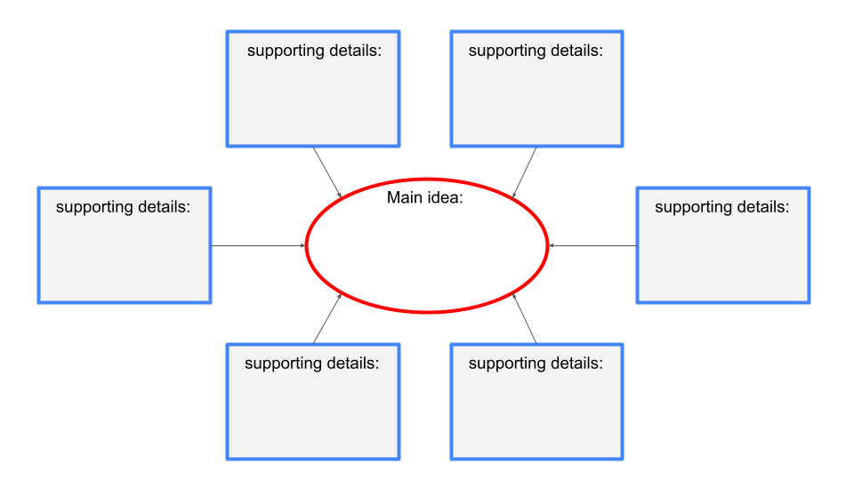“林丹九岁……，……。……，因为太累了。”

Task 6 Please read the second half of the second paragraph, and fill out the graphic organizer below.

“但是不管……，……。……冠军。”

What helped Lin Dan achieve the championship?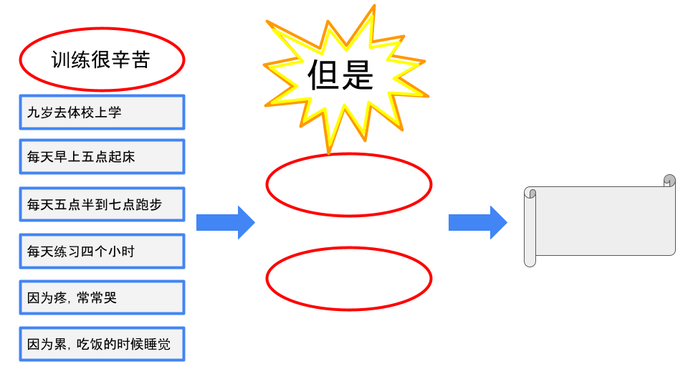

Task7 Use the following graphic organizer with the sequence of time to list what Lin Dan did at different times.

| Time  什么时候 | What  林丹做什么 |
| --- | --- |
| 小时候 |  |
| 五岁的时候 |  |
| 九岁的时候 |  |
| 十二岁的时候 |  |
| 2002年的时候 |  |
| 2004年到2008年 |  |